

**b**



**SPIMB SECURITY SERVICES**

**:**

C**OMPANY PROFILE**

**INTRODUCTION**

**Spimb Security Services Limited** is a newly well-established security company in Kenya. Our approach to security has evolved with the new challenges in security trends resulting to decline in the country’s security situation and as such, the crime rate also grows rapidly. With this and many more ideas in mind, we have come up with new criminological diverse approaches that are integrated with technological knowledge on how to counter evolving new high crime rates.

The challenge facing the country has been met head-on by – security Services; **Spimb Security services** is able to analyze the impacts of a combination of credible personnel and technology on access control system of physical security. It will also evaluate how technology and credibility of the security personnel has been used to improve on physical security with the aim of upgrading security in public places mostly due to the ongoing war against terror that have posed a threat to Kenyans hence the need to upgrade both technological and physical security. It’s a company, dedicated to inspect survey and study the condition and then provide the security solution most appropriate to the client’s situation through using our expertise –with quality, professionalism and customer satisfaction services.

Currently security Services product portfolio offers one of the most comprehensive choices from Security guards to Electronic Security Systems, computerized Access control systems and remote monitored Closed Circuit Television surveillance*.*

Our management and well trained staff are dedicated to ensuring continued training and development of our human resources as well as our technical expertise to meet current and future customer needs for viable solutions in the security industry.

**OUR THEORIES**

At **Spimb security Services Ltd** we trust our clients will benefit from choosing us as we invest the time and effort to ensure that we:

* Fully understand your security threats and vulnerabilities
* Provide the appropriate level of security response through a combination of manned security, changes to process, technology and/or patrols to mitigate your risks
* Provide a solution tailored to Kenya Breweries individual requirements
* Provide a competitive price
* Use a robust management system and highly motivated management
* Work with high-quality recruitment and vetting processes
* Implement excellent training and security practices, developing service excellence
* Provide excellent contract support with experienced and smooth implementation
* Provide on time delivery, to agreed standards
* Provide a reliable, secure and extremely robust service, maximising our clientele security
* Create clear, accurate and timely management reports
* We are receptive and responsive to innovative ideas

We totally believe that all our clientele will benefit by selecting **Spimb security limited** that’s to provide professional security solutions to address current and future needs.

**OUR MAIN OBJECTIVES**

* To be effective and timely in responding to our client’s or customer’s security needs and requests
* Emphasizing constant and close relationship with our contracted customers
* The management is dedicated and committed in striving to offer personalized services to our clientele.

This is as a result of our management policy that is proactive, dynamic and results oriented. All activities are planned and executed to maximize cost effectiveness for our customers and for Spimb Security Services Ltd.

**CUSTOMER CARE AND PUBLIC RELATIONS**

At Spimb we highly prioritize our customers; we respect that our customers are seeking a service provider not only able to provide the service but also capable of continuously offer high - quality services. It is for this reason that we have made Customer Service Management a top priority across all our service lines.

Spimb security officers will form the first point of contact between you and your customers and the first impression created should reflect your superior customer friendly brand. Spimb security officers undergo training in customer care and will carry themselves in the most presentable and courteous manner while on duty. This means that your reputable image will be enhanced through this interaction point.

**OUR PRODUCTS & SERVICES**

1. **Guarding**

**Spimb Security Services limited** has a potential, well established and defined recruitment and performance policies that place only the best security officers at assignments. Observation, Monitoring and supervision of guards at assignments are carried out by three levels of management – supervisors (visits to each assignment during each shift), shift managers (spot checks) and senior managers (random checks). All this has enabled us to provide guard services for high demand customers.

All Security officers are thoroughly vetted by management during recruitment. The internal vetting procedures include a thorough interview of all Security Officers, past employment history and reference letters. External vetting procedures include, but not limited to authentication of documents presented including Certificate of Good Conduct and other academic documents.

1. **Investigations.**

We are professionally certified investigators that are capable in conducting all types of investigation including accidents, HR policies, contracts and criminal investigations that involve forensics etc.

1. **Electric Fencing.**

Our professional fences provide a first-line deterrent and earliest detection of an intrusion for our customers and have a life expectancy of nearly a decade. The energizers can incorporate solar power sources in line with the prevailing power situation in the country.

1. **Training.**

Our guards and guardettes must attend a four week training course before posting. Those who fail course work exams are left out and not issued with certificates. The lessons given to the security officers is tailor made to suit specific clientele and industry requirements.

1. **Cash Transfer Service.**

We have the capacity to provide the service and our good relationship with the government especially Police gives us the flexibility to respond to our customers within the required time. Our procedures ensure private, sensitive and classified information is handled with utmost diligent and confidentiality.

1. **Alarm response/ Back up**

**Control Room**: The Control Centre is the heart of our operations. We have a designed modern control room with the radio alarm systems, which offer the highest level of reliability as the transmitter systems installed in our clients’ premises carry out a self-test every 24 hours and report the results to the central system in our control room. The technical design of the transmitters offers zoning and other advanced features providing the back-up crew with information relating to the area of attack, progression of an intrusion and condition of security personnel on the ground. We maintain a Double Cab Pick-ups as it offers more comfort and safety to the occupants including Police Officers. The response vehicles are strategically located to be able to respond to the furthest assignment within an average of 5 minutes. They however are on patrol a lot of the times because of the police presence in our vehicles.

1. **Car or vehicle tracking services.**

We monitor and track different client’s vehicles and cars through the most updated GPRS system and we specialize in systems that incorporate cost effectiveness and the latest technology when it comes to monitoring our clients and customer’s sites and vehicles.

1. **CCTV Systems**

We have the capability to offer a wide range of products from normal cameras to digital recording and remote surveillance. The camera specifications available include cameras designed to complement the interior of any office and the ones designed for industrial sites. The technical execution of the installations follows international standards and hence ensures the best quality of images and durability of the system.

1. **Access *Control***

We have access control solutions for all variety from simple card-to-open systems, biometric system access to comprehensive reporting and live real-time monitoring high security systems. The system can also combine asset tracking to prevent loss of electronic equipment (e.g. Laptop computers, mobile phones) from premises.

|  |  |
| --- | --- |
| GUARDING | Specializing in all disciplines namely: Commercial, Industrial, Retail, hospitality and institutional. We provide personnel that will contribute to the enhancement of our business partners’ image. |
| INTERCOMS; VIDEO CALLS & VOICE CALLS | Video door phone enables a home owner or a tenant to talk with a person who is standing near an entrance gate and simultaneously to see them on the monitor screen and to control a door release.  The system may be extended with additional monitors or audio phones. Each video door phone set contains: monitor with power supply, outdoor station, audio, phone. |
| INVESTIGATION | In-house assistance with professional comprehensive and  Discreet investigation if required. In addition, ISS has formed an Investigation network which is continuously interacting with various law enforcement agencies. |
| RISK ANALYSIS | As we ensure that our solutions are 100% specific to client’s needs, in this regards the first step will be conducting a  Detailed “**Client Risk Profile**”. We have dedicated teams of specialist who carry out expert and thorough situation analysis with recommendations on best way to mitigate risk. Risk Analysis and Management Survey is submitted to the client along with SSS Proposed Solution. |
| VENUE SECURITY | Our innovative strategies, systems and secure preferred network  Ensure our competitive advantage for services ranging from small, medium and national events. |
| 24HR REACTION UNIT | Our Mobile Response Team will go out of their way to  Assist our clients wherever necessary to ensure clients peace of mind, confidence and to ensure that security and planning needs are fully met. SSS works on 24/7/365 basis, a response team with a dedicated communication link is always on standby for the clients emergency requests. |

|  |  |  |
| --- | --- | --- |
| **ALARM SYSTEMS** | | |
| **Wireless Alarm** | With color LCD screen and keyboard on the Host  Ability to send SMS to 3 groups of mobile numbers and call up to 3 preset cell phone numbers by turns while sounding alarm | Power - Standby battery  Ability to inquire the status of alarm Host by SMS  Ability to arm/disarm by the |
| keyboard on the Host, |
| remote controller or SMS |
| **Fire Alarms**  C:\Users\admin\Desktop\iks\alarm 2.PNG | This system is able to give accurate,  reliable fire detection and notification | Provides precise, life-saving information  Can be relied upon to help protect any type of facilities |
| **Siren Alarm Padlocks** | This is a padlock with an alarm sound of 10 Db | Can be used with/without alarm Tamper proof  Water proof  Corrosion resistant |
| Has a dual shock with |
| movement sensor |
| **Solar Powered Wireless Alarm** | It is an alarm system that gives the user the option of using solar energy |  |

**CCTV INSTALLATION.**

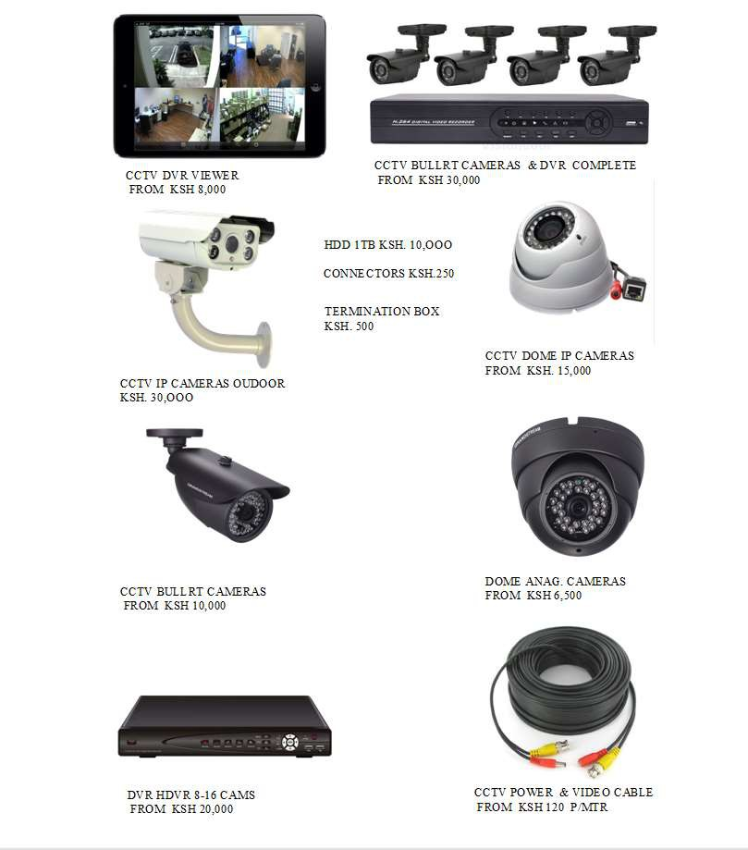

**Our client base:**

* Corporations
* Institutions
* Companies and Closed corporations
* Non-Governmental Organizations
* Government parastatals
* Diplomatic missions
* Industries
* Private individuals

**Spimb Risk Management Approach**

* Risk assessment - carries out a security audit and evaluates the existing safeguards
* Risk analysis – identifies the possible hazards and analyzes your vulnerabilities
* Risk Control - implement sound safeguards to control, mitigate or eliminate risks designed a complex integrated security solution i.e. an intelligent mix of manpower and electronic Security management systems
* Work closely with your home and or organization’s safety team to improve on safety and fire safeguards in order to minimize or eliminate exposure to identified threats.
* **SPIMB** personnel will play a major role in your Home or organization’s environmental health and safety program.
* Support with first aid – we are privileged to have a good relationship with the Kenya RED CROSS that provides the immediate first aid services in case of a need.

**DIRECTORS & SENIOR MANAGERS**

The following personnel form the core of our operations and are constantly in touch with our field staff and customers either through telephone or radio communications. They are responsible for dissemination of information and co-ordination of communication both with our clients and field staff where high degree of precision is required.

**Managing Director** - Mr. Stephen Okitwi is a UoN, University graduate having majored in Forensic and Criminal Investigations in security studies. He specialized in investigations and also holds a diploma in Security Management from (KICJ) Kenya Institute of Criminal Justice. He has served and has experience and knowledge of Police services having served in various Police special Units as a police officer. He is also a professional Group security Manager having worked with both local and Multinational Organizations. Currently is the security officer at Ponty Pridd holdings Ltd and Previously senior Security supervisor at Coalition Security Ltd. He has over thirteen years’ experience in the Security industry. He is the managing director **SPIMB** Administration Departments and is also charged with customer liaison activities and a Consultant in all security related Matters.

**Director** – Topister Ingwe has considerable knowledge and experience in management. She does the entire consultant on company policy and objectives.

**Financial Controller –** Mrs. Maryanne Mwaura is a University Graduate having majored in Accounting and Auditing. She heads our accounts department. She has versed financial management experience with both local and multinational organizations in the accounts department

**Operations and Administration –** Mr. James Oliwa – Graduate from Egerton University and a holder of BA in Security Studies.

**IT - Manager** – Mr. Ian Soi is in charge of the IT- Department. He has a wide knowledge in regard to IT field and matters. He has vast experience in the Electronic System work – erecting of prior masts and pilot masts communication aerial/antennas. Having training in maintenance of Electrical Equipment’s, installation and communication. Access Control, Electric fencing activities in the company. He is responsible for Alarms Units, CCTV, in VHF, UHF & HF two ways Radio and telecommunication.

**Benson Ochula -** Benson has been a Controller with our company since the time of its formulation. He has trained and received in - house and institutional training in both operational and finer details of Public Relations and communications. He is an experienced Controller who has been in security industry for more than ten years.

**HUMAN RESOURCE** –Winnie Makena.

**Selection & training**

The guards before being recruited into the company and for training have to meet the requirements set out by the company.

**Requirements**

* Kenyan Citizen
* Age 25 to 35 years
* Height 5.8” and above
* Academic qualifications - must be a Form Four Leaver with a Mean Grade of D+ and above.
* A certificate of good conduct from the C.I.D.
* Letter from area chief
* National Identification Card
* A letter of introduction from two referees
* A letter from previous employer
* Preference given to Ex- NYS and National police service men and women.

**Training**

After qualifying as a recruit, they sit for an aptitude test and only those who qualify are allowed to start with training. They undergo a four-week training course coordinated by SPIMB Training team. The training ensures that the recruits are fully conversant with responsibilities and procedures involved in their duties.

**Subjects /Areas covered**

* Company code of conduct
* Crowd control
* Drill
* First aid
* Fire fighting
* Self defense
* VHF Radio Communication
* Telephone Communication
* Search techniques
* Patrol
* Dealing with public
* Customer care
* Discipline
* Anti-terrorism
* Public Relations
* Use of Guards equipment
* HIV/Aids

**Bankers**

Family Bank

Moi Avenue, Cargen Branch

P.O. Box

Nairobi.

Cooperative Bank,

TRM branch

P.O. Box

Nairobi

**Insurers**

* CIC General Insurance Company Limited –Box 59485-00200 Nairobi